1. To understand JPA, understand cache.
2. Cache is internal thing which is not exposed by JPA API.
3. 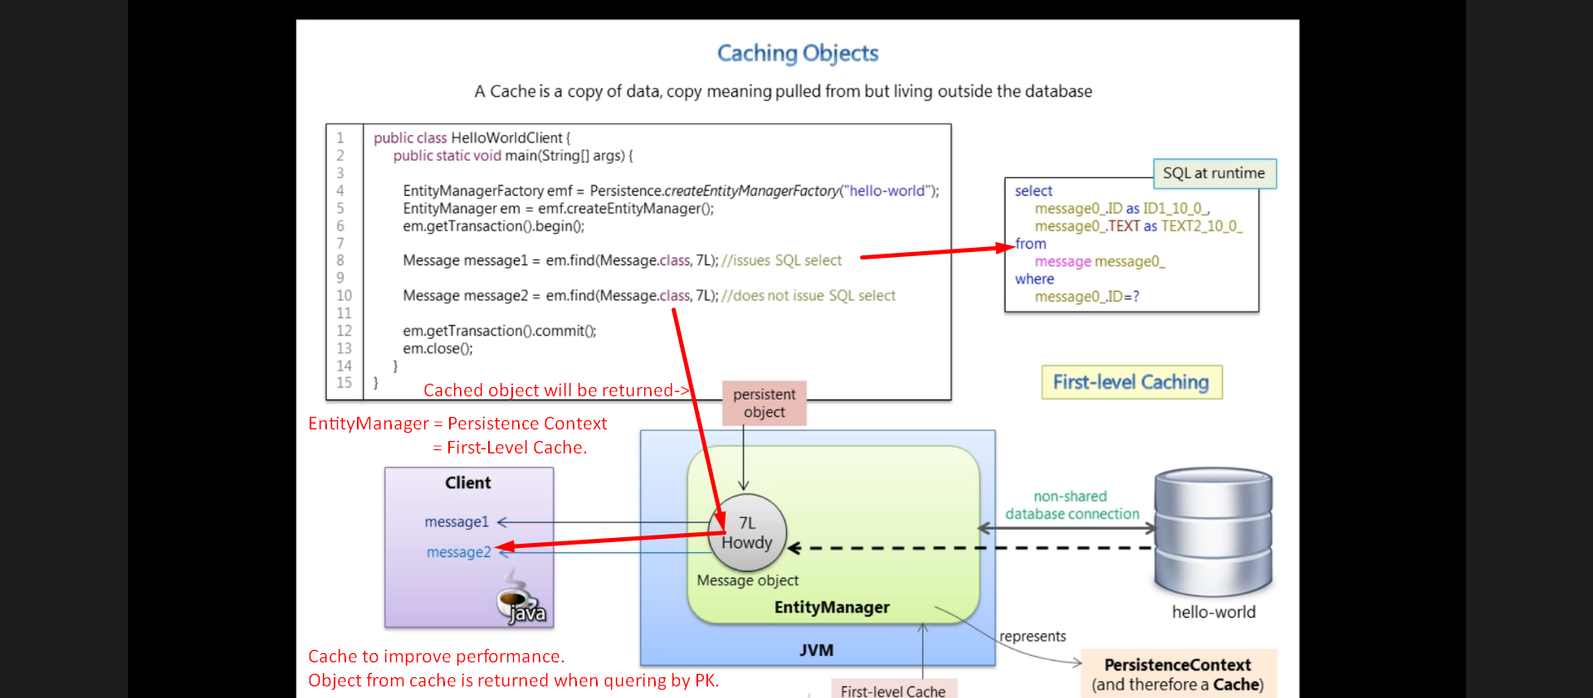
4. What if we have two different entity manager = First-Level Cache and we’re querying them for object by same ID.
5. 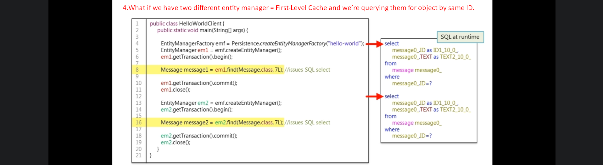
6. 